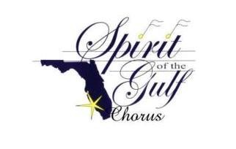

**GLAM, GLITZ & GLITTER**

**Saturday, February 16, 2019, 11:00AM, $35**

**Pelican Preserve Golf Club**

**9802 Pelican Preserve Blvd, Fort Myers, FL 33913**

**Fashions presented by** [](https://www.belk.com/)

**FASHION SHOW**

**Come see the latest in…**

***Cruise Wear, Athletic Wear,***

***and Casual outfits.***



**WALK AWAY WITH SOMETHING WONDERFUL!!**

**Silent Auctions Stunning Coach Bag Raffle 50/50 Raffle**

**BE DELIGHTED BY PERFORMANCES FROM**

***SUNSHINE CELEBRATION & TAMIAMI SOUND***

**TREAT YOURSELF TO THE RENOWNED *PELICAN PRESERVE HOT BUFFET***

***TICKETS: $35 per person***

***FASHION SHOW BUFFET***

***GREAT ENTERTAINMENT CASH BAR***

***FOR TICKETS, PLEASE CONTACT:***

**Jackie Barfield, 239-898-4084 (Spirit of the Gulf)**

**Sandy Royal, 239-985-1795 (Pelican Preserve)**